v

**FUNDAMENTALS OF PROGRAMMING**

**(WIX1002)**

**ASSIGNMENT TECHNICAL REPORT**

November 2017 – 13 December 2017

**Group Name : wukawuka**

**Project : Googol**

**Tutorial Group : 1**

|  |  |
| --- | --- |
| **NAME** | **MATRIC NUMBER** |
| **Chooi He Lin** | **WIF190009** |
| **Ng Yong Ming** | **WIF190041** |
| **Fahad Aqeel Thakur** | **WIF190708** |
| **Srija** | **WIF190709** |
| **Chong Wei Hao** | **WIF190501** |

Title of assigned project: Googol

In this modern age, Internet has become the essentials in everyone’s life. One of the services we get from Internet is searching. Undoubtedly, Google will first come to our mind when we have question about assignment, question about love or even what to eat tonight. With all these convenient services provided by Google search engine, the assignment requests us to design and create a simple offline search engine to salute the greatness of the Google search engine.

Requirements of the project:

* Search engine
* Calculator
* Currency Exchange
* Mini Game

Approach taken to solve the task

Search engine with GUI  
 We face some problem to obtain the html content from Alexa because security system blocked these websites. We manage to use Java Swing and Jsoup to create search engine that provide simple user interface and searching feature for our user by excluding those blocked websites in our search engine function.

Calculator with GUI  
 We initially create a calculator system that can only works for one parenthesis. Due to the shortage of the function, we tried to improve the calculator to run under multiple parenthesis but we faced problem to include multiple parenthesis with an effective method. Finally, we come out with recursive method to solve the problem to work with multiple parenthesis. We use Java Swing to create a simple functional calculator that can works on multiple parenthesis and multiple operator with simple user interface.

Currency Exchange  
 We did the currency exchange in the range of South East Asia based on the minimum requirement of task given. To make our program better, we provide direct currency exchange system that can convert most of the currency in the world including all currency in South East Asia.

Mini Game with GUI  
 The mini game needs minimax algorithm to work but we do not understand the algorithm and could not apply in this mini game. Hence, we enter all the possibilities of the game to allow the game to function. But still we think the code is redundant so we try to find related algorithm to find the best move for our program. However, the final step to merge the java code with GUI failed until we tried for few times to make it works. This mini game which is Tic Tac Toe can works for single player or multiplayer with simple GUI using Java Swing.

Program Output

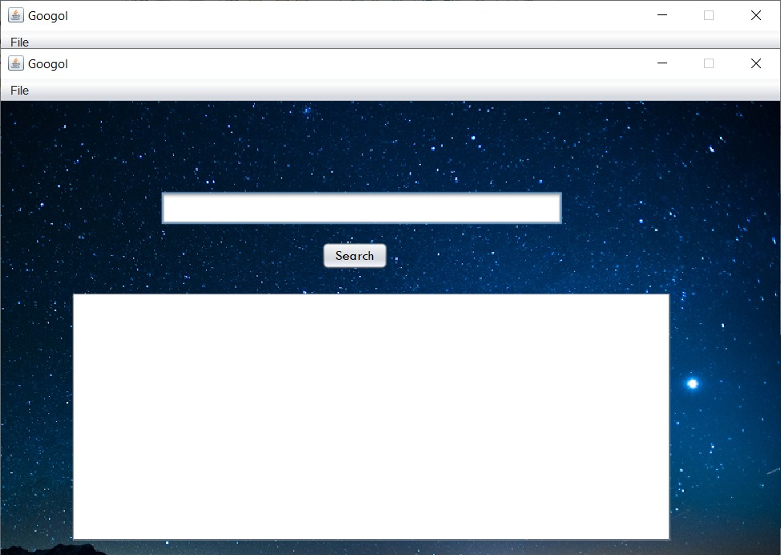Search Engine Graphic User Interface(GUI)

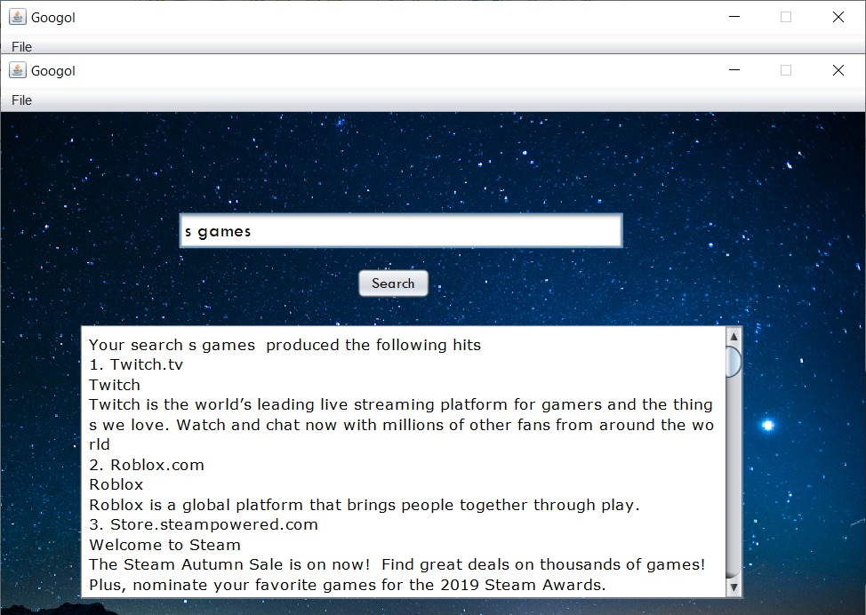Searching Feature

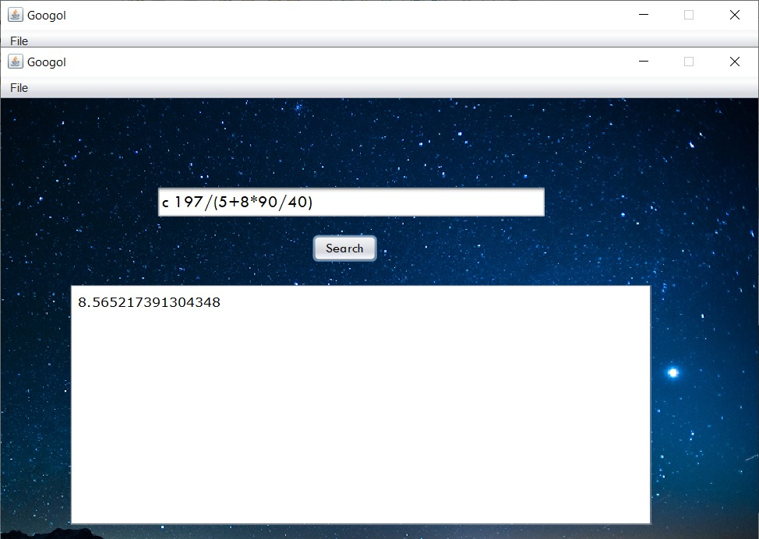Calculator on search bar

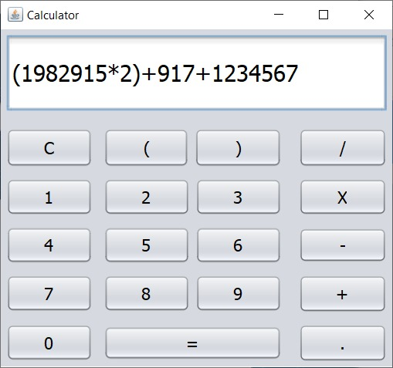Calculator

Enter the calculation

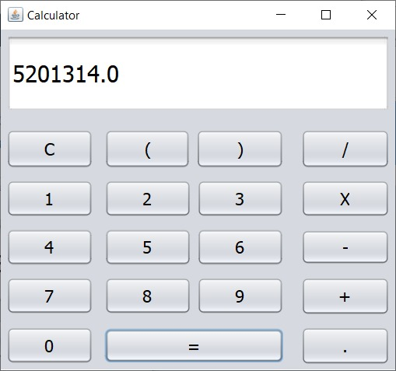

Display the result

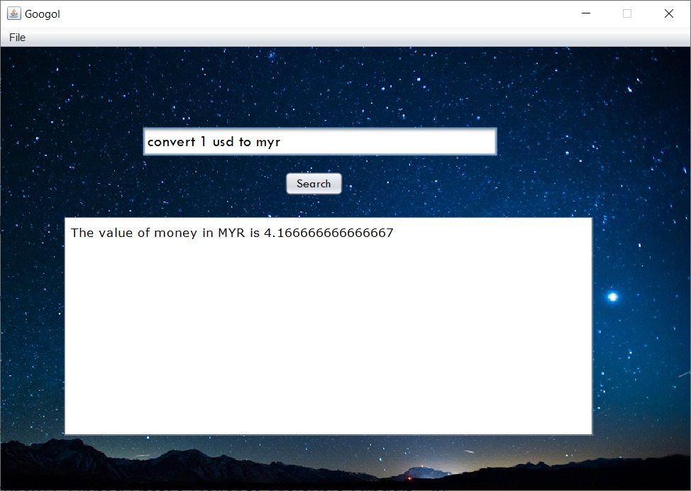Currency Convertor

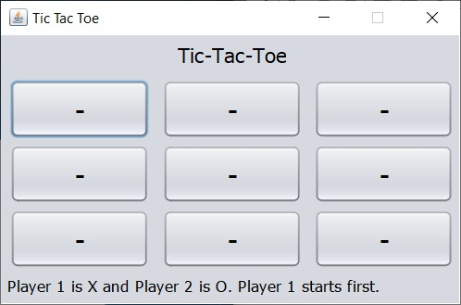Tic-Tac-Toc in GUI

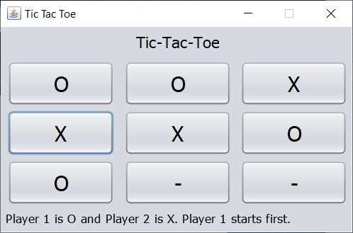Initial Board

Player VS Player or Player VS Computer

Translator in GUI

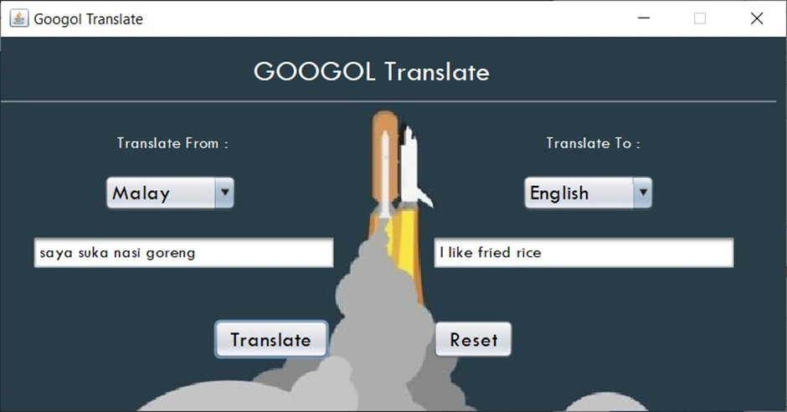

I love fried rice too!

*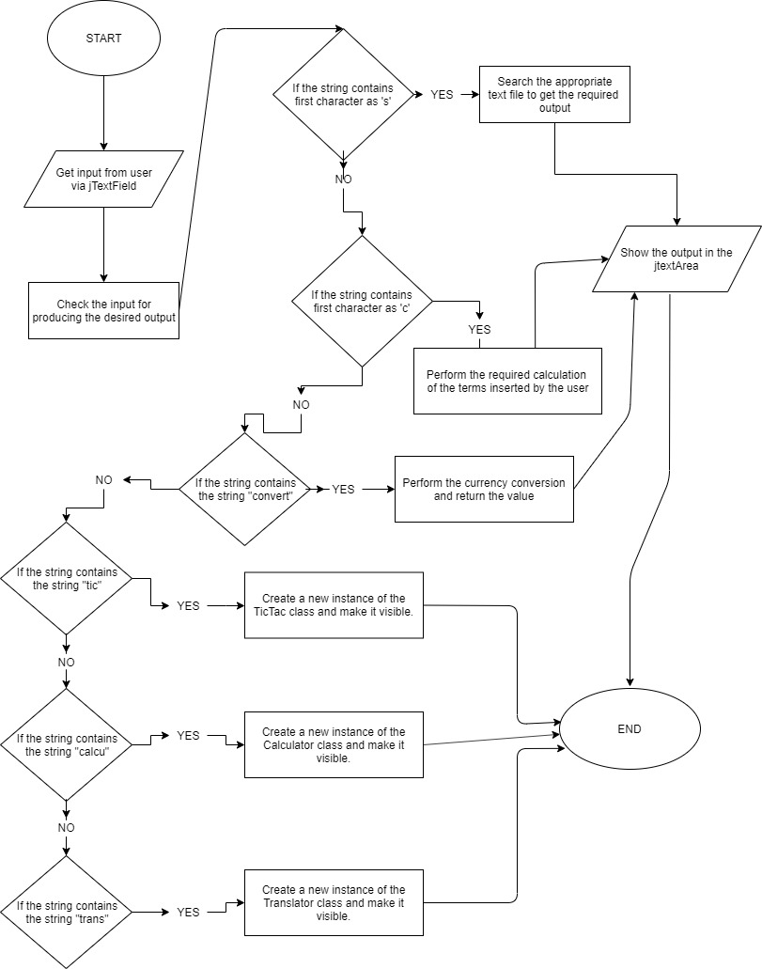The Main Method Flow Chart*

*Searching Flow Chart*

Display the title, content and URL of the website

Get input of lists of website from Alexa website

Compare the user input to the keyword lists in the text file

Get input keyword by user

Store URL from Alexa website in a text file based on category

*Currency Convertor Flow Chart*

Get the type of money input

Display the value of money in output money type

Change the value of money from Malaysian Ringgit to the output money type

Change the value of money from input money type to Malaysian Ringgit

Get the type of money output

Get the value of money input

*Tic-Tac-Toc Program Flow Chart*

YES

NO

NO

DRAW !!

YES

AI Win !!

AI Win !!

Win?

Full?

NO

NO

NO

YES

YES

YES

NO

Clicked?

Cell Empty?

Make the move on board

Run Minimax Algorithm

Make the move on board

Computer make first move

Buttons listen to user’s click

Initialise the board

Human First?

YES

Cell Empty?

YES

NO

YES

NO

NO

Win?

Make the move on board

Make the move on board

Run Minimax Algorithm

Full?

Clicked?

Buttons listen to user’s click

Initialise the board

Start

*Calculator Flow Chart*

**YES**

**Parenthesis**

**Number?**

**End?**

**Operator?**

**NO**

**NO**

**NO**

**NO**

**YES**

**YES**

**YES**

**Add Into Number Array List**

**Return Result**

**Start Operation**

**Add Into Operator List**

**Parse the String**

**START**

**Get Expression As String**

Modules

The search engine is able to perform searching feature. Not only showing the URL but the program able to show the title and the simple description for that particular website. We manage to use Jsoup to scrap the content from the HTML code of the websites. All the text is stored in the text file for the searching feature because the program has to run without Internet. Apart from that, the program rendered using Java Swing to create user interface and convenient searching for our user.

Initially, the calculator system can only works for one parenthesis. Due to the limitation of the calculator, we tried to improve the calculator by able to calculate multiple parenthesis calculation. Finally, we use recursive method to solve this problem. To make user able to perform calculation like in reality by pressing calculator button, we use Java Swing to create a simple user interface for our caculator.

The currency convertor able to perform currency exchange in South East Asia. We decide to choose MYR as base currency for the conversion. So, the currency to be converted will changed to MYR, then the MYR amount will change to the desired currency. This save us time to get all the exchange rate from any currency to another currency. To make our program better, we provide currency exchange system that can convert most of the currency in the world by referring to website XRates.

The mini game use minimax algorithm to work. The method is able to perform the findBestMove method for computer and human player Hence, we are able to know what best move the human player will make so the computer can perform the move to block or avoid the human to make his/her best move. This mini game which is Tic Tac Toe can works for single player or multiplayer with simple GUI using Java Swing.

The extra feature our program provided is translator. By using online API, the program able to translate among 5 languages.